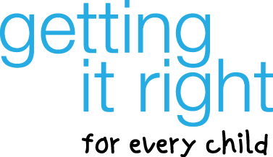
GIRFEC: Roles and responsibilities across the wellbeing pathway
multi-agency training (1 day)
The Children and Young People (Scotland) Act 2014 supports the wellbeing of all children and young people by expanding the Getting It Right for Every Child (GIRFEC) approach. It is important that staff and volunteers across all services and agencies working with children, young people and/or their families, have an understanding of roles and responsibilities of the Named Person, Lead Professional and themselves across the Wellbeing Pathway. The course considers these roles and responsibilities at each stage of the Child Wellbeing Pathway.
Course aim: To improve participant's knowledge and understanding of the different roles and responsibilities across the Child's Wellbeing Pathway.
Course Learning Outcomes:
- Understand the role of the Named Person
- Understand the role of the Lead Professional
- Understand your responsibilities, including:
- Sharing Information
- Providing a Wellbeing Assessment
- Contributing to a measurable Child's Plan

Training is held at the College of Nursing and Midwifery in Kirkcaldy,
9.30 am to 4.00 pm.

Thursday 1st September 2016, Classroom 4
Friday 4th November 2016, Classroom 1
Wednesday 14th December 2016, Classroom 4
Thursday 26th January 2017, Classroom 4
Monday 13th February 2017, Classroom 4
Tuesday 21st March 2017, Classroom 4

To book please use CLMS (for Fife Council employees)
or contact Joanne Erskine, joanne.erskine@fife.gov.uk
03451 55 55 55 + Ext 445315

